LESSON 9 APRIL 28, 2023
SUBJECT: Faith of a Canaanite DEVOTIONAL READING: Psalm 61:1-8
BACKGROUND: Matthew 15:21-28 LESSON: Matthew 15:21-28
MEMORY VERSE: Then Jesus said to her, “Woman, you have great faith! Your request is granted.” And her daughter was healed at that moment. Matthew 15:28 NIV
LESSON AIM: To show how to exercise humility, persistence, and faith in seeking divine favor.

INTERNATIONAL SUNDAY SCHOOL STUDY OUTLINE
I. A FAITHFUL PETITION: MATTHEW 15:21-22
- Where does this week’s lesson take place? Locate on a New Testament map. Was this region Jewish or Gentile? Matthew 15:21
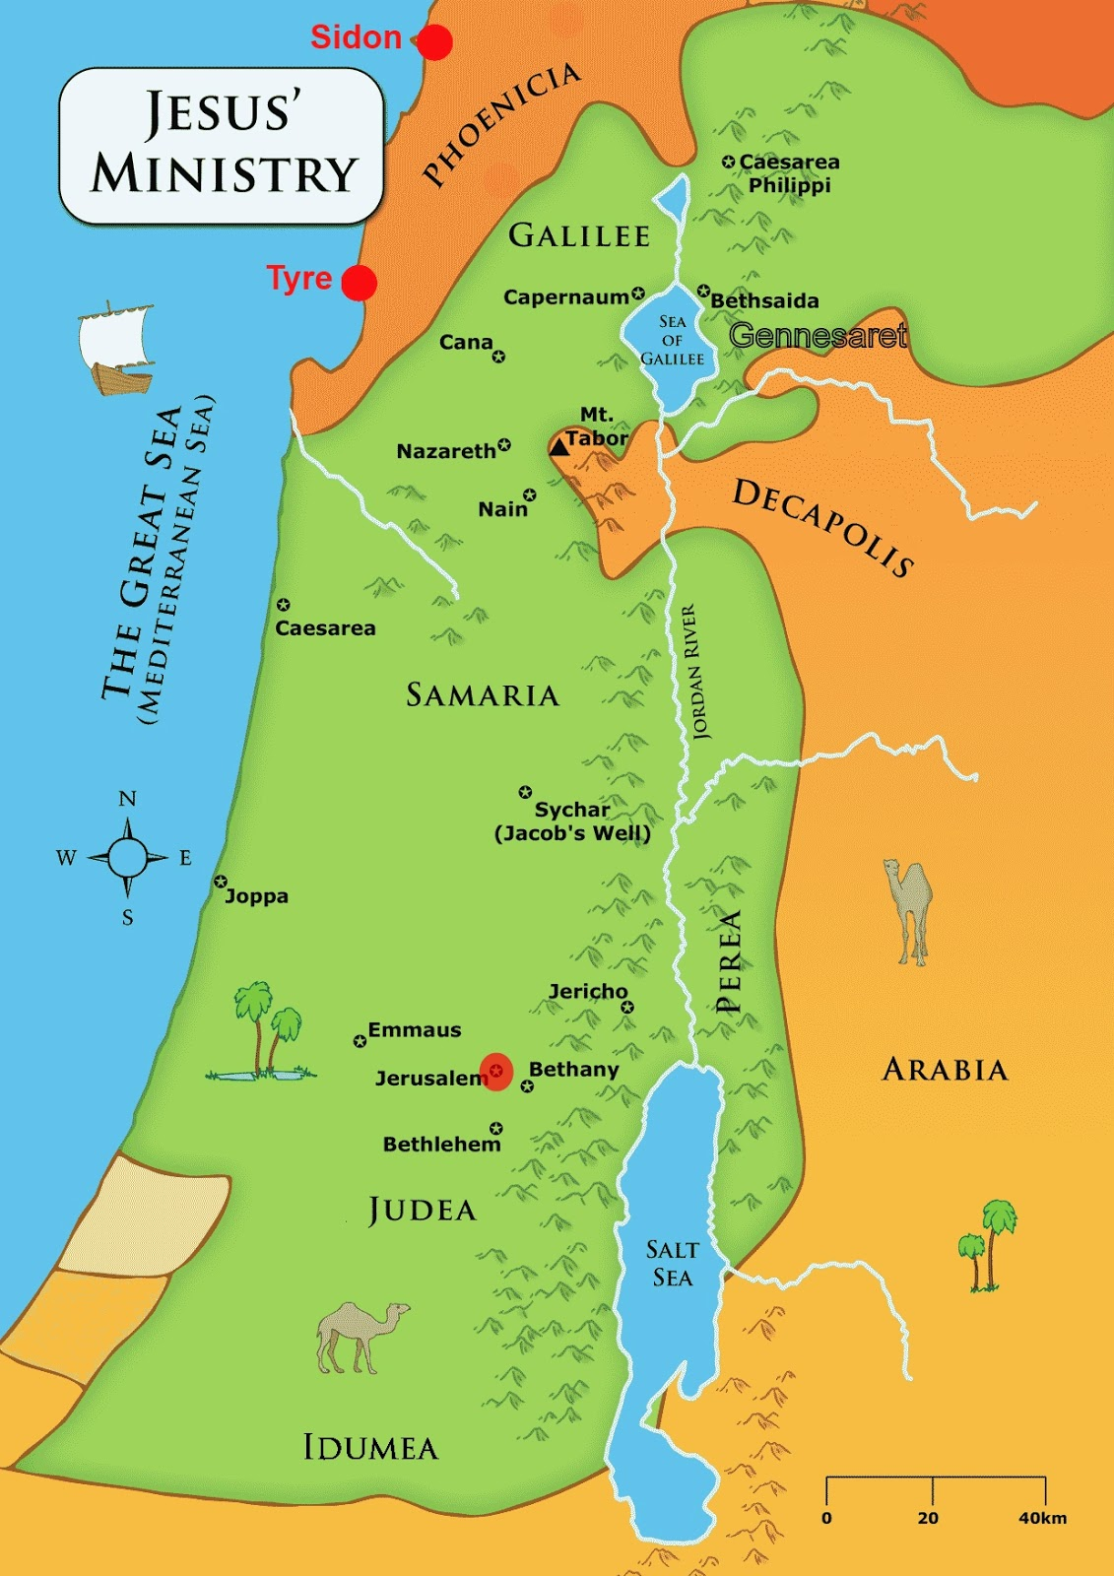
- The region in which these cities were located had a long history of paganism and opposition to the Jews. How had the people of this region previously affected the Israelites? Judges 10:6
- Why do you think Jesus went to this region?
- Who approached Jesus in the region of Tyre and Sidon? What was the nationality of this person? Matthew 15:22a (Mark 7:26)
- How did this Canaanite woman address Jesus? Matthew 15:22b
- What plea did this Canaanite woman make to Jesus? Matthew 15:22b
- Upon whose behalf did this Canaanite woman go to Jesus? What was the condition of this person? Matthew 15:22c
- How do you think this Gentile woman knew of Jesus and His power since most of His ministry was in Jewish regions? Matthew 4:23-25
II. A FAITHFUL PERSISTENCE: MATTHEW 15:23-28
- What was Jesus initial response to the Gentile woman? Why do you think so? Matthew 15:23a
- How did Jesus’ disciples want Him to respond to the Gentile woman? Why? Matthew 15:23b
- What could the woman have done because of Jesus’ silence and the disciples’ annoyance?
- What did Jesus explain to the Gentile woman about His mission? Matthew 15:24
- Why do you think Jesus was initially sent to the Jews as His priority and focus? Consider the following:
- Jews were God’s historic chosen people through the Abrahamic Covenant. (Genesis 12:1-3; 17:1-7)
- Jesus was born a Jew. (Luke 1:26-35; John 1:9-14; Romans 1:3)
- Jesus came to fulfill the law and the prophets given to the Jews. (Matthew 5:17; Galatians 4:4-5)
- Jesus came to gather the lost sheep of Israel. (Matthew 15:24)
- Jesus came to prepare the Jews to carry His message of salvation to everyone. (Matthew 28:16-20)
- Were the Jews Jesus saved to continue their ministry only to other Jews? Matthew 28:19-20
- How did the woman respond to Jesus’ initial silence and His first comment? What should this teach us? Matthew 15:25 (Read in several Biblical Versions)
- What was Jesus’ second comment to the Gentile woman? What do you think Jesus meant? Matthew 15:26
- What do you think the terms “children”, “dog” and “bread” refer to in Matthew 15:26?
- Do you think Jesus was degrading the woman with His remarks in Matthew 15:26? Why or why not?
- How did the Gentile woman respond to Jesus’ seemingly discouraging remark? What did the woman desire? What does this tell us about the woman? Matthew 15:27
- What was Jesus trying to draw out of the Gentile woman? Did He reach the end result? Matthew 15:28ab
- What was the result of the Gentile woman’s faith and persistence? Matthew 15:28c
- Why do you think the woman did not attempt to argue with Jesus? What was her only concern? Matthew 15:22
- How did Jesus praise the Canaanite woman? Matthew 15:28a
- How can the Canaanite woman’s encounter with Jesus be misunderstood?
- What should we do when our prayer life or faith seem to be weak? Luke 11:1; 17:5
v. 11:1 |  |  | v. 17:5

SUMMARY AND DISCUSSION
- What does persistence in prayer and faith indicate?
- How was the Canaanite woman’s faith tested?

