LESSON 12 FEBRUARY 18, 2024
SUBJECT: Faith in Times of Trouble Devotional READING: Matthew 8:18-27
BACKGROUND: Daniel 6:1-28 LESSON: Daniel 6:10-11, 14, 16, 19-23, 26-27
MEMORY VERSE: “My God sent his angel, and he shut the mouths of the lions. They have not hurt me, because I was found innocent in his sight. Nor have I ever done any wrong before you, Your Majesty.” Daniel 6:22 NIV
LESSON AIM: To be inspired to keep the faith and pray without ceasing.

INTERNATIONAL SUNDAY SCHOOL STUDY OUTLINE
I. DARIUS’ FIRST DECREE: DANIEL 6:1-7
- Locate the Medo-Persian Empire on a map.
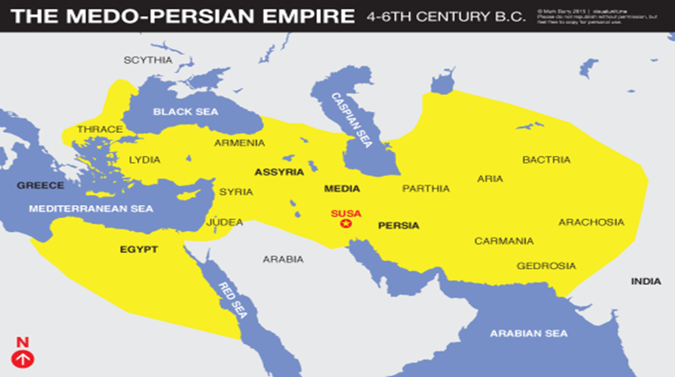

- What were the administrative positions in the Medo-Persian Empire? Daniel 6:1-2, 7a
- What position was Daniel appointed to in Medo-Persian Empire? Who was the king? Daniel 6:1-2
- What did the king intend to make Daniel in his kingdom? Why? Daniel 6:3
- What did the other officials plot against Daniel? Why? Daniel 6:3-4a
- What was the result of the other officials’ attempt to find fault in Daniel’s reputation and work? Daniel 6:4bcd
- What conclusion did Daniel’s enemies reach regarding him? Daniel 6:5
- What did Daniel’s enemies specifically do to try to discredit him and put him at odds with the king? Daniel 6:6-7a
- What was the suggested consequence if someone did not obey the decree? Daniel 6:7b
- What did Daniel’s enemies do to make sure the decree was binding? Daniel 6:8
- What was King Darius’ decision about the officials’ petition? Daniel 6:9
- How many days would King Darius to be considered a god? Daniel 6:7
II. DANIEL’S DETERMINATION: DANIEL 6:10-11
- What did Daniel do after the king’s decree had been signed and published? Daniel 6:10
- What did Daniel’s enemies do after the decree had been published? Daniel 6:11a
- What was Daniel doing when his enemies found him? Daniel 6:11b
III. DANIELS DEATH SENTENCE: DANIEL 6:12-18
- What did the officials next do after they found Daniel? Daniel 6:12a, 13
- What was the king’s initial response to the official’s report? Daniel 6:12b
- How did the king feel once he found out it was Daniel who was guilty of breaking the decree? Daniel 6:14
- What did the officials do once they discovered that the king did not want to punish Daniel? Daniel 6:15
- What was the king forced to do with respect to Daniel? Daniel 6:16a, 17
- What hope did Darius voice about Daniel after he was placed in the lions’ den? Daniel 6:16b
- How was Darius affected by his decision? Daniel 6:18
IV. DANIEL’S DELIVERANCE: DANIEL 6:19-24
- What did Darius do the next day after sentencing Daniel? Why do you think so? Daniel 6:19
- What did Darius want to know when he arrived at the lions’ den? What does this reveal about how he had been influenced by Daniel? Daniel 6:20
- What were Daniel’s first words to Darius? Daniel 6:21
- How did Daniel explain his deliverance? Daniel 6:22ab
- Why did Daniel say he was delivered? Daniel 6:22c
- What did Daniel remind Darius? Daniel 6:22d
- What did Darius do after hearing Daniel’s voice? Daniel 6:23
- What happened to those who had falsely accused Daniel? Daniel 6:24
V. DARIUS’ SECOND DECREE: DANIEL 6:25-28
- What did Darius wish on his subjects? Daniel 6:25
- What did Darius direct all the people of the empire to do with respect to God? Daniel 6:26a
- What did Darius describe about God’s character? Daniel 6:26b
- How did Darius describe God’s kingdom and His dominion? Daniel 6:26c
- What did Darius say about God’s general acts and personal acts toward Daniel? Daniel 6:27
- What became of Daniel after his deliverance and the new decree? Daniel 6:28
SUMMARY AND DISCUSSION
- What does the sixth chapter of Daniel reveal about Daniel’s faith and God’s faithfulness?
- What saved Daniel? Are we always saved as Daniel?

